Entrepreneurship Coaching

(PROF. DR. MARTIN A. BADER)



GREENBOX

Team Members:

* Megan Smith (User Experience Design)
* Pia Meier (Automotive Production Engineering)
* Milly Attree (User Experience Design)
* Chandan Mahat (Automotive Production Engineering)

# Declaration

**Declaration in accordance with § 18 Para. 4 Nr. 7 APO THI**

I hereby declare that this thesis is my own work, that I have not presented it elsewhere for examination purposes and that I have not used any sources or aids other than those stated. I have marked verbatim and indirect quotations as such.

Ingolstadt, 13.12.2020

(Signature)

________________________

First name, Surname (all team members)

Table of Content

Declaration i

1. Introduction and Team Presentation 1

2. Product Idea: Greenbox 2

2.1. Greenbox: A Solution to Global Issues 2

2.2. Greenbox: Our Value Proposition 2

2.3. Problem and Solution: Energy Consumption along the Supply Chain 3

2.3.1. Problem and Solution: Germany’s Destructive Eating Habits 4

2.3.2. Problem and Solution: Food Waste 4

2.4. Customer Research 5

2.4.1. Quantitative Customer Research: The Questionnaires 5

2.4.2. Qualitative Customer Research: The Interviews 5

2.5. In Summary: The Greenbox Solution 6

2.6. Revisiting the Value Proposition 6

3. Business Development 7

3.1. Competition 7

3.2. Journey from Skateboard to Car Model 8

3.2.1. Skateboard Model Description 8

3.2.2. Car Model Description 8

3.3. Marketing 9

3.3.1. Logo, Image and Branding 10

4. Business Model 11

4.1. Business & Revenue Model 11

4.1.1. Business Model 11

4.1.2. Revenue Model 11

4.2. Logistics 11

4.3. Cost Structure 11

4.4. Finance 12

4.5. Risks 12

5. Current Status and Outlook 13

6. Bibliography 14

7. Attachments 14

List of Figures

Figure 1 Ideation 13

Figure 2 Startup Development Phases 13

List of Tables

Table 1 Cost Structure Analysis 12

# Introduction and Team Presentation

We are the team of Greenbox, and we want to raise better food awareness. Our mission is to offer a digital service which enables a connection of local farmers and producers with their customers. We give people a sustainable solution for their grocery shopping of fresh and healthy goods. Due to less transportation of our regional grown food the GreenBox service generates less carbon emission compared to a usual food purchase in a discounter.

Our concept aims to inform the customer in detail about the product and the production of it. Our long-term vision is to offer our service all over Germany and to create a nationwide, green, and sustainable food network with regional farmers.

The team behind “Greenbox”:

# Product Idea: Greenbox

Greenbox is a service that collects fresh produce from local farmers and delivers it the homes (or other desired pick-up location) of our customers in a way that limits energy, food, and packaging waste as much as possible. In the rest of this section, the problems that necessitate such a service and how Greenbox intends to solve them will be outlined.

## Greenbox: A Solution to Global Issues

The idea for Greenbox came out of necessity. The service is directly inspired by one of the United Nation’s seventeen Sustainable Development goals: Sustainable Consumption and Production. This goal outlines specific targets in order to achieve a “sustainable future” and to address “global challenges” that the world faces (United Nations, “17 Goals to Transform Our World.”)

These United Nation’s 2030 targets for Sustainable Production and Consumption are numerous (with twelve in total) and have an equal amount of global impact and importance. However, Greenbox has identified three specific targets as actionable items within the scope of our service that we can positively contribute. These targets are:

“**Target 12.2:** By 2030, achieve the sustainable management and efficient use of natural resources.

**Target 12.3:** By 2030, halve per capita global food waste at the retail and consumer levels and reduce food losses along production and supply chains, including post-harvest losses.

…**Target 12.8:** By 2030, ensure that people everywhere have the relevant information and awareness for sustainable development and lifestyles in harmony with nature” (United Nations, “Goal 12: Ensure sustainable consumption and production patterns.”)

Our proposed service, with its focus on the distribution of sustainably sourced produce, its strong attitudes toward decreasing food waste in combination with our intent to educate the community on the importance of food appreciation, see these three targets as integral components of our mission and value system.

## Greenbox: Our Value Proposition

The Greenbox value proposition is this: “Greenbox creates a sustainable ecosystem for fresh produce delivery.” In this proposition, we state the projected service we’re bringing to our customers (fresh produce delivery) as well as the value that we create (a sustainable delivery ecosystem) and the problem at-large we solve with this service (by default, unsustainability.)

This word “ecosystem” pulls a lot of weight in our proposition. We believe that in order to make progress toward the above-mentioned UN targets, Greenbox needs to become a fixed and reliable part of the community. We believe that we need to develop an ecosystem that survives and thrives without burdening the community with more waste and. Thus, the value we provide is not just fresh, healthy food. Part of the value we provide is a service that strengthens its community while simultaneously inflicting no ecological harm upon it.

In the next sections, Greenbox will describe various global sustainability issues which, in conjunction with research into our projected customer base, will provide the basis for the problems that our business intends to solve. This research will provide solid support for our value proposition, in addition to proving that Greenbox is a solution to not only local issues, but also in relation to the United Nation’s global 2030 Targets.

## Problem and Solution: Energy Consumption along the Supply Chain

The United Nation website also makes it clear that without more sustainable practices and attitudes about the world’s general consumption and production habits, the world is heading in a precarious direction*.* Their website states that “Should the global population reach 9.6 billion by 2050, the equivalent of almost three planets could be required to provide the natural resources needed to sustain current lifestyles” (United Nations, “Goal 12: Ensure sustainable consumption and production patterns.”)

Further research, however, provides additional reasons that a service like GreenBox can solve the problem of using the planet’s natural resources more wisely. For instance, consider the apple. When you buy an apple from the grocery store, chances are that it was exported from overseas. In the research our team conducted, we looked at the supply chain of an apple imported to a German grocery store from New Zealand.

The supply chain (and energy wastage) created by importing an apple from New Zealand to a German grocery store is immense in comparison to apples sourced through the Greenbox supply chain. The New Zealand apples take a 28-day journey aboard a “cool ship” which keeps them air-conditioned until they reach their port overseas. This trip consumes a massive 2.83 megajoules per kilogram of apples (Blanke & Burdick, 2005, “Food (Mlies) for Thought.”) For reference, one megajoule of energy is equal to one hour of watching a large TV (Genesis Now: Energy Efficient Engineers, 2020, “Energy Examples.) Which on the outset might not sound like much, but once you multiply that number by the hundreds to thousands of kilograms of apples being imported from overseas, it becomes quite significant.

In addition, New Zealand apples embark on many in-between trips aboard energy-consuming, air-conditioned trucks in order to end up at a German grocery store. This includes transport from the port to the packaging center and from the packaging center to the grocery store. And then of course there is a significant amount of energy wasted when the customer travels (by car) the average of 3km from their home to the grocery store to buy the apple (Blanke et al., 2005, “Food (Mlies) for Thought.”). In total, an imported apple from an overseas location like New Zealand, consumes 7.49 Mj of energy per kilogram of apples. Most of this energy consumption stems directly from transport methods like “cool ships” and air-conditioned trucks which travel hundreds and thousands of kilometers and consume vast amounts of energy to do so (Blanke et al., 2005, “Food (Mlies) for Thought.”)

**The Greenbox solution to this problem:** Our service removes as many of these wasteful “in-between trips” as possible. In the Greenbox transport model, most of the energy consumed to get an apple from the orchard to the customer’s home is just the standard energy used during apple cultivation. After being harvested at the orchard, the apple makes a comparatively small trip to our warehouse in order to be sorted for delivery. From there, it is delivered to the consumers home in a carbon neutral way. (Transport logistics will be described in greater detail in Chapter 5.) In comparison to an apple imported from New Zealand, Greenbox projects it’s supply chain will only consume 3.21 MJ per kilogram of apples. This is a direct result of our shortened, local supply chain. Other than apple cultivation, the only other major contributors to energy consumption in our supply chain are the initial transport and cooling, as well as a small amount of reserved for packaging.

However, Greenbox acknowledges that our service and process still have the potential to contribute waste at various stages in the process. We are committed to offset this waste by joining forces with several programs that will help our company achieve carbon neutrality. (Such as a service that plants trees on behalf of our company.) In summary, though the Greenbox model significantly cuts down energy wastage along the supply chain, any opportunities for energy waste will be identified and compensated for the company to reach and maintain carbon neutrality.

### Problem and Solution: Germany’s Destructive Eating Habits

Further research supports the fact that the German population’s overall eating habits are a problem for sustainability as well. For instance, in 2010 Germans adopted slightly unhealthier habits (such as consuming slightly more meat, wheat and dairy products.) This slight change resulted in 215,000 hectares of land in other countries being converted to cropland (Worldwide Fund for Nature, 2012, pg. 32.) For reference, this is an area of land the size of the State of Saarland. In addition, 40 million tons of CO2 were released, a number “equivalent to half of Austria’s total 2010 GHG emissions” (WWF, 2012, pg. 36.) This proves that even slight negative differences have a huge negative impact, not just in Germany but the rest of the world as well. If Germans switched to significantly more sustainable diets (eating 44% less meat and increasing produce intake by 75%) the country would significantly reduce its CO2 emissions to the order of 300 million tons of C02 per year (WWF, 2012, pg. 40.) Even if the country adopted even slightly healthier eating habits, the positive effects would be noticeable, with an even slightly healthier diet reducing Germany’s carbon footprint by 14% (WWF, 2012, pg. 46.)

**The Greenbox solution to this problem looks like this:** By delivering locally sourced produce, Greenbox circumvents the issue of converting foreign land to cropland because it is using the land and resources that already exist inside of Germany. Additionally, with most of our product options being fruits and vegetables, our service exposes consumers to the type of healthy, sustainable diet recommended by the Worldwide Fund for Nature. This will be compounded by the fact that part of Greenbox’s solution includes educational outreach on the problems caused by unsustainable diets. Greenbox believes that the more people are educated about food sustainability choices, they are more likely make sustainable, healthy choices when giving the option.

### Problem and Solution: Food Waste

Food waste at the consumer level (after the grocery shopper has bought the food and taken it home) is devastating to sustainable consumption and production practices. The United Nations states that “Each year, an estimated one third of all food produced – equivalent to 1.3 billion tones worth around $1 trillion – ends up rotting in the bins of consumers and retailers or spoiling due to poor transportation and harvesting practices” (United Nations, “Goal 12: Ensure sustainable consumption and production patterns.”)*.* The “throw away” attitude of the average German consumer wastes not just food but the land and other resources that it took to produce that food. When viewed from this perspective, consumers waste 2.4 million hectares of land, an area the size of the country of Turkey (WWF, 2012, pg. 7.) This is an immense amount of wastage that could be avoided if consumers understood the importance of using (and buying) their food wisely.

**The Greenbox solution to this problem looks like this:** Part of the Greenbox business plan is to educate our consumer and provide resources that enable them to connect with the food and those who grew it. The business plans to provide insights into who grew a consumer’s produce (for example: specifying what farm grew their apples.) Typically, consumers don’t see who grew, harvested and transported their food to them. Greenbox believes that this disconnection between how food is grown and how it gets to the consumer is an instigator to the lack of food appreciation in German culture. By attaching local places and faces to products, Greenbox won’t just tell consumers to appreciate their food, but given them a motive to do so.

## Customer Research

In order to form a better understanding of how to mold this service into something our customers would be attracted to, we performed multiple rounds of questionnaires and interviews. The target was to understand the customers thoughts and feelings to supply a customer-oriented service which brings the maximum value to their lives.

### Quantitative Customer Research: The Questionnaires

The online questionnaire was designed to be answered by as many people as possible and gather as much information as possible about their habits, wants, needs, and attitudes toward sustainable consumption and production.

The questions were carefully chosen to reveal for example the answerer’s demographic like age and gender to see a trend in the given answers. The different answers of specific age groups can help us to focus more on our target group. Gender information allows us to make gender specific advertising for example. An additional important factor is the potential customers current attitudes toward sustainable foods and their propensity for purchasing regional and locally produced goods. An aspect which is related to that, is to understand why or why not people consuming regional products. To have an idea about their current produce purchasing habits help to offer the right range of products and to scale our business. Aspects here are the importance of price and variety.

**Result:** The survey was conducted over the course of a week and generated nearly 50 responses and produced to strong mixed results in certain questions. Our mostly male participants of a broad age range made us understand that sustainable food is important to them and that in their current shopping habits they mostly try to buy regional products. In addition, they believe that most people do not currently shop at local farmers because they are invisible and do not advertise themselves. The majority also felt that laziness is a decisive factor in not buying directly from a local farm. The fact that farmers' markets are not offered daily in the cities also makes it difficult for our respondents to make a local choice of food. A gratifying result of our survey was that the majority believed a rather smaller variety at reasonable and fair price is sufficient and satisfactory. The most favorable price is currently not the crucial purchase criterion in their purchase behavior. Almost all of them agreed that buying regional products helps to reach our CO2 targets. The most chosen brand name was “Greenbox” because it can be related to healthy, fresh products which are delivered in sustainable packaging.All in all, the questionnaire encourages us to follow our idea, because the answers indicate a need for such a product in the interviewed group.

### Qualitative Customer Research: The Interviews

The in-person (or digital via Zoom) interviews were designed to get a deep look at customer wishes, attitudes, and motivations by prompting them with open, leading questions. These conducted qualitative interviews allowed us to ask persons directly and to scrutinize their answers directly to exactly understands the thoughts and argues.

Again, demographic information was collected in the beginning to know how the answers can be interpreted. Our service was briefly described before the participants could have given insight in what they would wish for in a website related to our service. Such information is important to directly meet the customers´ expectations and also to save iteration steps in the development of a digital product. To establish a price structure and possible delivery options a feeling for the willingness to pay for such a service is interesting. Since our service should raise awareness for sustainability in the daily food consumption, the closing question was about the participants current feelings about their grocery shopping habits and how they would feel if they bought local food. The idea was to get a confirmation that shopping of qualitative and regional produced goods can generate a positive feeling to the customers.

**Result:** The GreenBox team conducted four of these qualitive interviews. Deep insights in terms of needed functions and services on the website were given during the interviews. The desired structure of the website and also relevant product information of the offered goods were described by the participants. The general feedback given was positive so that most of the interview partners confirmed their interest and willingness to pay for such a service. The generation of positive feelings related to a sustainable and regional food purchase was also confirmed during the gathering of the interviews.

In conclusion it can be said that it was imperative to get a concrete understanding of what a potential customer thinks about sustainable consumption and production in relation to regional food. An utmost empathy with potential customers is essential to provide an attractive customer-oriented service which gives maximum possible value to the user.

## In Summary: The Greenbox Solution

Our research into the world’s sustainability issues and the attitudes/needs of our customer base have presented several problems, both in relation to global concerns and gaps in the market. In summary, the GreenBox solution to these problems is fourfold:

**Solution 1: Deliver fresh, local produce directly to our customers:** Greenbox’s primary service is collecting fresh produce from local farmers and delivering it to our consumers with the least amount of waste and processing required. The Greenbox service aligns with many consumers views such as a) consuming imported produce contributes negatively to CO2 emissions b) consuming local goods is better than not doing so and c) that they would partake in such service because of its convenience. Thus, or service is solving a need that exists for many people.

**Solution 2: Reduce (or offset) typically waste associated with imported or grocery store products such as packaging and carbon emissions :** Greenbox has carefully laid out it’s produced transport and delivery logistics in order to cut back on energy consumption and carbon emissions typically caused by such transport/delivery. However, as acknowledged above in Chapter 2.3, we will offset any unintended wastage created by our service by taking part in carbon neutrality programs. Part of our solution is to achieve carbon neutrality as soon as possible, in keeping with our proposition to become a sustainable service.

**Solution 3: Reduce local food waste through communication with farmers and educational outreach to our customers:** As outlined in the research above, a crucial part of reducing food waste is making sure there is no loss of harvest during the supply chain. Greenbox solves this by keeping the supply chain short. Additionally, Greenbox plans to abate food waste by establishing a connection between the consumer and the produce delivered to them. Our hope is that this implementation will create more value around the received crops that doesn’t exist when a consumer buys imported grocery store produce.

## Revisiting the Value Proposition

To restate our value proposition: “Greenbox creates a sustainable ecosystem for fresh produce delivery.” Our proposed service provides value at a variety of different levels, with the delivery of fresh produce being just the surface value that we provide for our customers. The true value of Greenbox is what we are capable of providing for the community as a whole, due entirely to the company’s view that solving global sustainability issues are actionable goals, and that action must begin at the local level in order to make a difference.

# Business Development

## Competition

The worldwide online shopping offer is almost limitless. You can order nearly everything from all over the world and get it right to your front door within a (few) day(s). Not only electronics, clothing and books are purchased the comfortable way also food is more and more ordered via the internet. This trend can be also observed in Germany, especially in the current pandemic situation, were every step out of the own home increases the risk of an infection. To order the weekly grocery shopping online is not only the saver way now, it´s also the more comfortable and easier way.

The mission of GreenBox is to deliver fresh, healthy, and regional grown food from local farmers right to your home. Therefore, the most obvious way to offer such a service is to do that in the form of an online shop. In order to provide our customers, the best service and a specific platform for their personal needs we compared our idea with existing services that also distribute food online. So basically, we wanted to see what our competitors are doing good and tried to implement such good approaches. On the other hand, we gathered what our competitors are not doing perfect and forced us to make it better right from the start. This approach can help us to start faster with our service and not to lose to many times with avoidable iteration steps.

We compared our service with four other online food services. We selected three big players and one smaller competitor for the comparison to get a deep insight. Together within the GreenBox team we discussed which criteria we want to focus on in our analysis and agreed on the following eight criteria:

* **Regional products:** As our mission is to offer only regional grown goods the aspect of regionality of the provided products is the most important critera for us.
* **Wide choice:** Wide choice should not be confused with large selection of the same products (for example 3 different kind of cherry tomatoes). With this criterion we wanted to rate the regional choice of foods, so if for each type of fruit or vegetable a regional choice is offered. Of course, only for the products which are possible to be grown in Germany.
* **Connecting to producer:** We want to raise the awareness of our customer for sustainable diet. Therefore, our vision is to give the product a certain value with offering transparency. The origin of the goods and how they were produced is then obviously an important information.
* **Prices:** Our target is not to offer the cheapest choice on the market, but since we don´t have retailers in between, less transportation and no brands behind our products we want to offer fair prices. The focus is on the price of the product, not on transport, marketing and retail.
* **Delivery conditions:** As our brand name already indicates that we offer a green service also our delivery should be green. We bring our delivery with bikes and in a green packaging.
* **Payment:** This criterion should not indicate on how many different payment options are offered, but the innovation in the offered options. None of our competitors offers an option which we call “monthly bill”.
* **User experience:** We as a customer-oriented company want to add a certain value to the lives of our customers with our service. Therefore, the usability of our service product should be way better than the offered one of our competitors.
* **Additional Service:** As explained, we want to grant a better service for our target group than our competitors. We are offering additional services such as: office delivery, monthly membership with benefits and much more. In the table below an overview of the rating is provided:

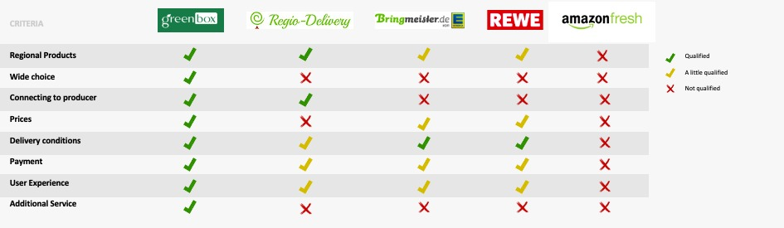

Figure 01

## Journey from Skateboard to Car Model

### Skateboard Model Description

As a beginner we consider all the parameters of a cost structure and want to gather the potential customer awareness. As we all know WhatsApp is a costless marketing tool, so we decided to start via WhatsApp flyer which is most likely a booklet that contains the information of our brand as well as our product and services. In the WhatsApp booklet we listed all food products with a product ID and price according to quantity, this enables the user to simply place an order via message or call. Moreover, the customer can pay cash when we deliver food to their door.

**Qualitative Interview**: To test this skateboard model, we conducted a qualitative interview. Where we asked for user’s opinion regarding the WhatsApp flyer Booklet. Many users said that it has a limited information. Also, customers don’t know that – is it an active flyer or an outdated one. So, in conclusion we came across that most of the users doesn’t pay attention to these types of marketing strategies and think that it is not a reliable source to place an order.

### Car Model Description

After getting feedback from our potential users. We all four company partners discussed together to improve our business marketing and ordering tool which should have up-to-date information, farmer details, food product information, pricing with quantity, delivery plus pick-up services, payment method etc. Therefore, we landed up a conclusion that we need to create a website which have all the functionality and features as a most reliable source of online shopping nowadays.

#### First Version Website

To start our first version website, we presented the company vision in an illustrated form on a home page where we depicted the whole product chain process of our business – As We “The Greenbox” are the bridge between the farmer and a customer. We want to establish the transparency in our business that nothing is hide from the customer. User can register for the first time with the basic personal details as well as can login on the home screen. The user credentials are entirely safe as we don’t sell these confidential data to the third-party as this is the policy of our company. After login user can access his/her account, can view purchase history, and can shop further. At the bottom of every page, we provide our contact details, social media links, newsletter subscription, delivery hours, pick-up stations, packaging, current info about supply, services etc.

We designed the website according to grid layout where we outlined each grid as an individual category. Our Main categories are – Fruits, Vegetables, Dairy products, Meat/fish, Our providers, and Co-operation. To start with the fruits screen – we structured the layout in a way that attracts the user attention in a most efficient way. If a user clicks on one particular fruit product, that opens up in a new page which will then have all the details of that product such as product history, diet, nutrition, farmer description, contact info, production region and so on. In this way customer also aware of the product from where it was harvested. We also provided the rating and feedback functionality on every product – In this manner, farmers will also get to know the quality of their product directly from the customer. This will motivate and help farmer to work upon their crop. Similarly, we designed the vegetables, dairy product, and meat/fish web pages so that all age group can access the website easily. This also embrace the overall user experience of our website. Furthermore, our providers screen also has same design layout to maintain the consistency of the entire website. In that web page user can access the individual farmer background history, contact info, varieties of production etc. This impart the feeling of connectivity to regional farmer, as this is one of the goals of our company. In co-operation screen user can see who others are supporting us to establish the green environment.

* **Website Usability Test:** We wanted to improve our website according to customer need, so we decided to conduct a usability test of our first version. Where we asked questions such as – to validate our website, to find any issues w­ith complex flow, to get the overall user experience and what features can be improved and added. We received the positive feedback from our potential users. They like how it is structured and also came up with suggestion to add more functionality and features, which actually helped us a lot. They suggested to have a multiple payment options, customized box, membership subscription and so on.

#### Final Version Website

In our final version we improved our website a lot, which you can see the visual in our attachments. The updated website has a membership subscription. This membership subscription has several benefits according to the category such as Basic membership allows user monthly payment of the ordered food stuff plus free pick-up of the box at DHL stations. Platinum membership has the advantages of basic as well as includes the cooling box services. The gold membership covers all the services from basic and platinum plus have home delivery benefits. Another added feature is a customized box where user can select any pre customized box and can exchange some food items in it according his/her diet requirements. The box has five different options to choose such as Fruits box (cost 15,99 euro), vegetable box (cost 12,50 euro), Meat/fish box (cost 22,10 euro), mix box (cost 17,50 euro), and raw food box (cost 12,30 euro).

To make it more flexible for the user, we streamline the checkout process where we implemented straightforward 3 stages to place an order. The very first stage is to register delivery address, second stage to choose payment option, third stage to fill the payment details. Additionally, we offer several payment options such as credit card, debit card, PayPal, net banking, cash on delivery etc. Customer can easily order and securely pay for it without any hassle. To proceed further, we also display the co-operation details on our website where user can look at the other businesses who are supporting us. We wanted to provide the transparency between the customer and supplier, this is the credibility of our business.

## Marketing

Establishing a business is not easy, and to promote our business we required right strategies to market. We thought about several aspects while considering the strategies, for example How to convey our message to the right audience in a correct manner that they understand our business goals of providing the Fairtrade to farmers as well as consumers. For that purpose, we started our business advertisements via Email advertising, WhatsApp flyer, Social media platforms, for instance - Facebook, twitter, Instagram, LinkedIn, Google plus, YouTube (videos) etc. These advertising sources have really boosted our business and increased the traffic on our website. Furthermore, we submit the article to online free advertising authorities to deliver our business memorandum to the specific customers in our region. In this way, both the farmers and the consumers can identify our intentions and can rely on us. We also worked on our website google search engine optimization keywords, which makes easier for the potential customer to find us on internet. Additionally, we offer yearly membership subscription which builds the relationship as customer becomes the member of our company, and also they get extra benefits of becoming a member like special holiday discount on particular food items, rewards, birthday box gift etc.

### Logo, Image and Branding

Greenbox has gone through several rounds of name and logo changes based upon customer feedback as well as the instincts of the team about how we wanted to position our company. The original name “GreenXpress” was generated from the idea that we are a “green” service (low waste and low energy consumption) so it was fitting to include that in the name. “Xpress” was added to the name to convey our role as a delivery service. This was in the early days of the company, when we were still operating under the idea that part of our business model would be getting the produce to our customers as fast as possible. Additionally, the script font of the original “GreenXpress” logo reflects the motivation of “express,” as it looks like it was written by someone in a hurry. After several rounds of outside feedback (from our peers, customer base and insights during team brainstorming sessions) we discovered that GreenXpress might be sending an “un-green” message of prioritizing speed over sustainability. It’s for these reasons that we decided to go back to the drawing board and come up with new branding for ourselves.

We relied on the intuitiveness of our customer base and let them choose between three different new names “GreenXpress,” “Greenbox,” and “GreenCart.” The feedback was clear that Greenbox was something the customer base saw being more easily tied to our service and mission. Due to these results, the company rebranded itself to Greenbox. The Greenbox logo kept its original colors or light green and dark green. However, because we were no longer an “express” service and had a better feel for who our end customer would be, the team created a logo that was meant to feel a little more premium and more calm and composed aesthetically. To elevate that “box” was a major part of our service, that word was created to look like it was literally inside of a box. Additionally, in keeping with the “green” motif, the “g” is stylized with a leaf, symbolizing our enduring connecting to the natural world.

In summary, the Greenbox branding evolved over the course of many business iterations, customer research and brainstorming sessions over how best to convey our image and message to the world. We hope that for our customers, this logo will become synonymous with a reliable yet sustainable to fresh produce and their community.

# Business Model

## Business & Revenue Model

### Business Model

Business Canvas Model of any Organization is the ‘Strategical approach’ which demonstrates how business is established. The idea of Business Model Canvas (BMC) is to visualize the business model and a startup idea. It is the way to test whether business idea makes sense or not. In simple meaning, without going into real world and instead of investing money to establish business, Business canvas model can be used to test its functionality, iterations, feasibility, and market response. ‘GreenBox’ business canvas model is also similar to the standard models. It consists of 9 blocks where each of the block contains different segments. Also, each of the segments are distributed in terms of business requirements.

### Revenue Model

Profitability of any business is directly depending on the revenue generation. GreenBox can generate revenues out of the margins and services provided to customers, addition to those revenue stream components, there is one more idea which is useful and interesting to implement for the ease of customer and provider. GreenBox is offering yearly membership subscriptions to the customers, depending upon the services, various charges are defined, which are as following:

* Premium Membership Card – 9.99 Euros
* Silver Membership Card – 14.99 Euros
* Gold Membership Card – 19.99 Euros

## Logistics

GreenBox aims to minimize Co2 emission to be reduced by some extent. In order to establish its goals, long distance transportations are eliminated. Since GreenBox is planned to initialize in Munich (Germany), local food products have to deliver to customer, so there are following two types of logistics which must be implemented to give satisfactory services to customers:

1. From Farmers to Warehouse
2. From Warehouse to Customer (Home Delivery)

GreenBox came with an idea to deliver the fresh food to the customers with the usage of bicycles. This is still a big challenge to bring raw foods from farmers to the Greenbox warehouse. In the first scale, GreenBox is asking farmers to deliver food (Vegetables/Fruits/Dairy Products/Meat etc.) to warehouse in given time slot. But problem comes when farmers don’t have their transportation mode. So, it has decided that initially logistics tie-up with Uber or rental vehicles can be used, also investment can be raised up for logistics and carbon footprint. Alternative of that, one more idea can be implemented, i.e. Using e-trucks for the delivery to customer and picking up the food from farmers to warehouse. Municipality and Environment sustainable department may be interested to implement such ideas so GreenBox is seeking for sponsorship for its initialization and successful establishment.

## Cost Structure

Cost Structure for a business startup is an important aspect as it defines the range of services and varieties which one can offer. So, Optimization of cost structure and minimizing the cost can lead to more profitability. GreenBox is estimating to face following fixed and variable costs in future keeping value preposition in mind:

Table Cost Structure Analysis

|  |  |  |
| --- | --- | --- |
| S. No | Cost type | Description |
| 1 | Set-up (Initial) Cost | System setup for Contacting various Farmers, Large Inventory set-up, Reusable Boxes for packing purpose, Deep Freezing/AHU/Duct system for products to store (Also its maintenance cost) |
| 2 | License Cost | Single time license cost for business setup and then commercial taxes on running business |
| 3 | Inventory/Storage Cost | Rent for a storage area of products including miscellaneous costs |
| 4 | Packaging Cost | Cost for Coolant/ wrappers/printing etc. Payment to warehouse staff and scrap |
| 5 | Pick Up Station Cost | Various pick up stations to return the empty reusable boxes |
| 6 | Advertisement Cost | Flyers, Newspapers, Banners & Charges to promote the service through different online website |
| 7 | Creation & Maintenance of Website/Mobile App | Online website and Mobile App to sign-up, check the availability of product & price and then adding into cart to order (Pick and Save) |
| **8** | Logistics Cost from Farmer to Warehouse | Option a – Tie-up with Uber  Option b- Electrical trucks |
| 9 | Delivery Cost | Payment to delivery boys on successful of each delivery to customer |

## Finance

GreenBox initialization is possible only if all required funds can be raised for its successful implementation. As of now, for Business startup, personal fund raising, Insurance, Loans, Sponsorships etc. are the primary key factors which can be involved. For long term vision, Various strategies can be applied. One of the major aspects to grab the marketplace is to get the customer trust and their satisfaction (Customer Segments). GreenBox tends to grow higher in near future with its value preposition, and financial segments like cost structure, profitability & balance sheets can be optimized with increasing number of customers and their trust towards the brand ‘GreenBox’.

## Risks

Risks in business start-up or in running business is a common term which is used very often. But when there is no risk, there are no chances of Innovation. In the endless journey of Entrepreneurship, from idealizing the thoughts to modelling, Prototyping, Designing, Initializing & Successful running business, even after that risks are the part of business model. Setting up GreenBox is a risk in terms of Investment & occupying place in market (Customer trust and Brand value). In order to avoid severe risks of GreenBox business model, prototyping & testing are done in each MVP. In the journey of evolution of final business model, various surveys, customer feedback, brainstorming and optimization are done in each step and every prospective of ‘GreenBox’.

# Current Status and Outlook

The founding process of a company can be also separated into certain phases like known from project management or product development. To visualize our current status, we decided to show it within the chart below:

Figure Ideation

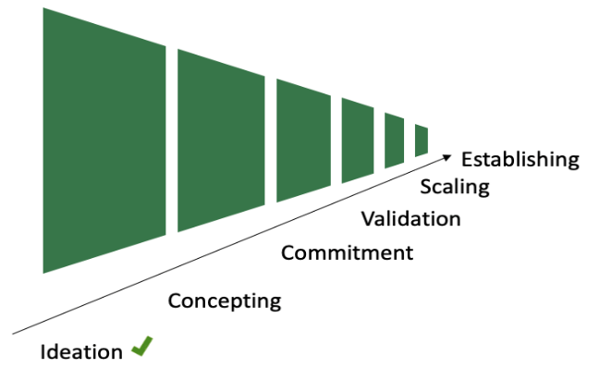The given report is a summary of our first founding phase “Ideation”. We have set-up a team of four skilled, motivated, and young people who are ready to start. We developed a scalable service idea which gives a certain value to our target market. Research work, competition analysis, surveys and interviews were done to get deeper insight into the topic and to understand the need and thoughts of our customers. In addition, we established a website prototype to start the iterative improvement process of it. Also, first cost structure ideas were calculated to set the basis for the next steps.

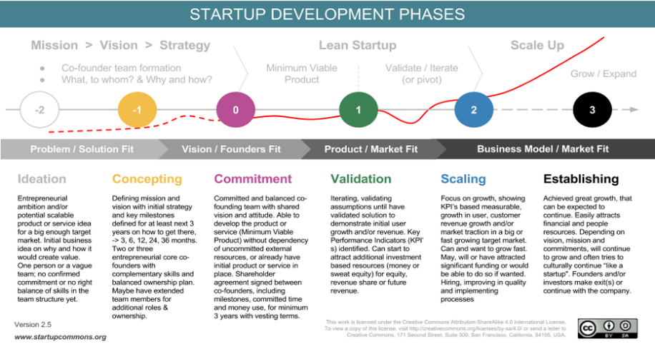 All in all, we are ready to sharpen our idea into a real product and to manage the upcoming challenges. We are ready to transform our mission into a green service which connects our customers with local farmers. We want to start as soon as possible giving people a sustainable and green choice for their grocery shopping of fresh and healthy goods.

Figure Startup Development Phases

# Bibliography

* Blanke, Michael & Burdick, Bernhard. (2005). Food (Miles) for Thought-Energy Balance for Locally Grown versus Imported Apple Fruit. Environmental science and pollution research international. Retrieved from <https://www.researchgate.net/publication/7756944_Food_Miles> _for_Thought-Energy_Balance_for_Locally-Grown_versus_Imported_Apple_Fruit
* Genesis Now. (2020). Energy Examples. Retrieved from genesisnow.com.au/reference/energy-examples/
* United Nations. (2020). Goal 12: Ensure sustainable consumption and production patterns. Retrieved from <https://www.un.org/sustainabledevelopment/sustainable-consumption-production/>
* WWF. (2012). Climate change on your plate. Retrieved from https://www.wwf.de/fileadmin/fm-wwf/Publikationen-PDF/Climate_change_on_your_plate.pdf

# Attachments

|  |  |  |
| --- | --- | --- |
| S. No | Description | Page No. |
| 1 | Pitch 1 | 15-16 |
| 2 | Pitch 2 | 16-19 |
| 3 | Prototype | 20-24 |
| 4 | Usability Test | 25-25 |
| 5 | Questionaries & Surveys | 26-34 |

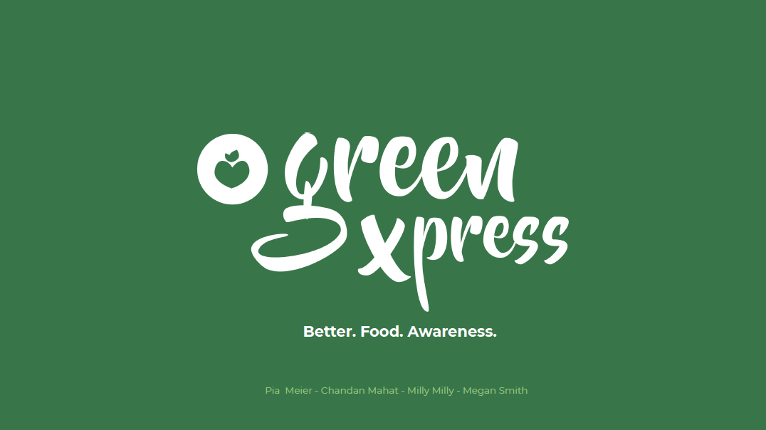

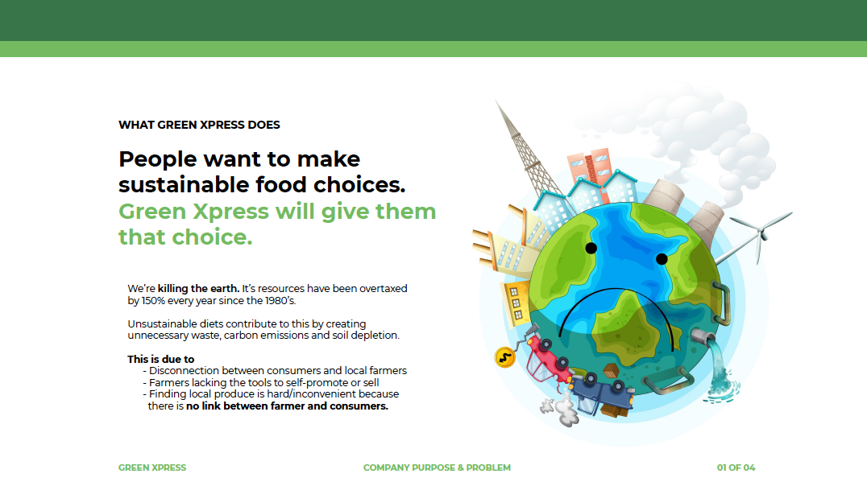

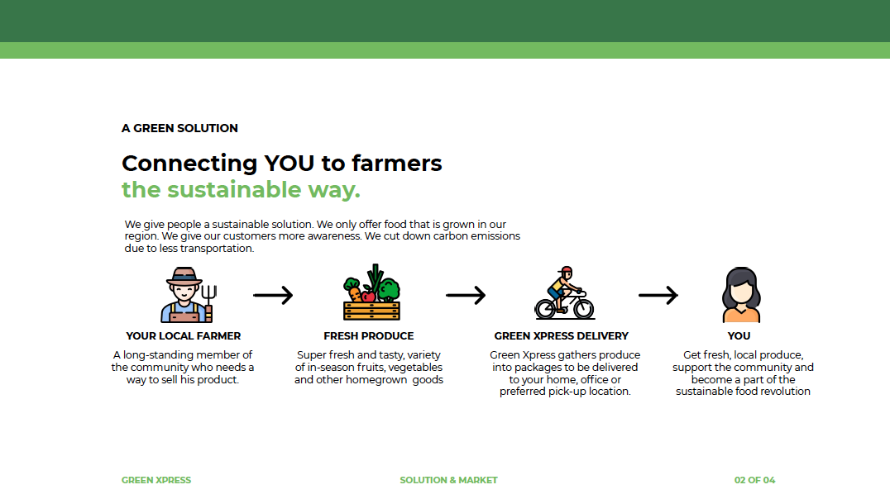

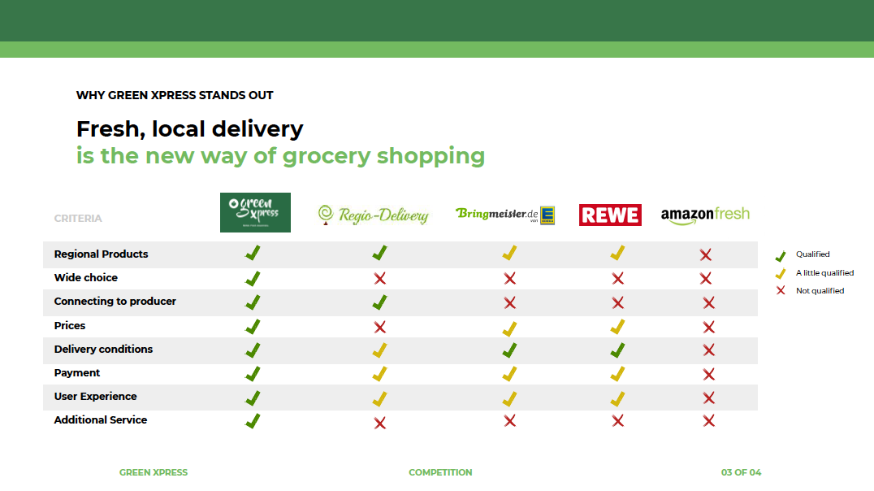

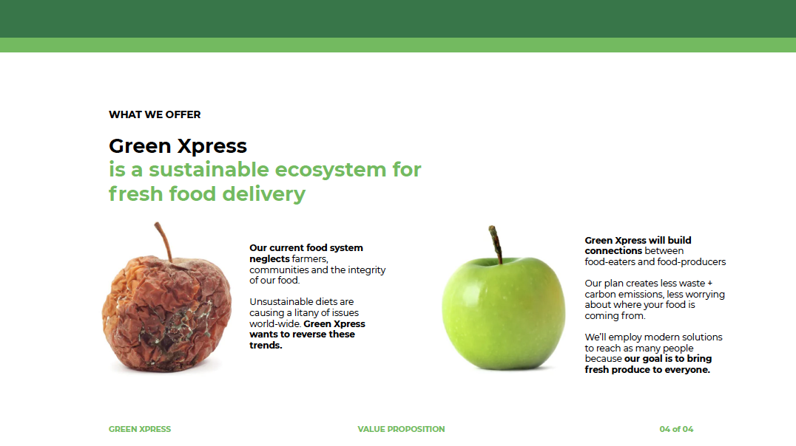

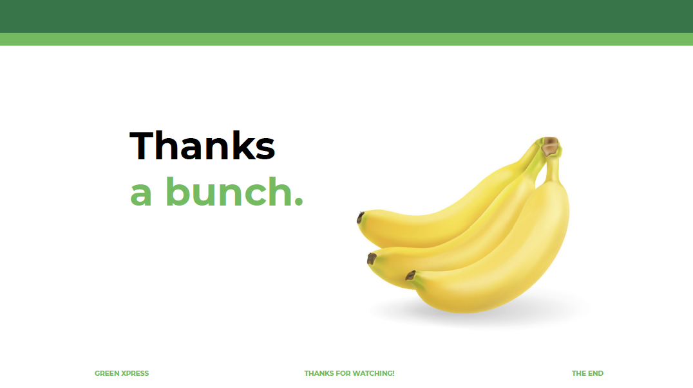

2nd pitch:

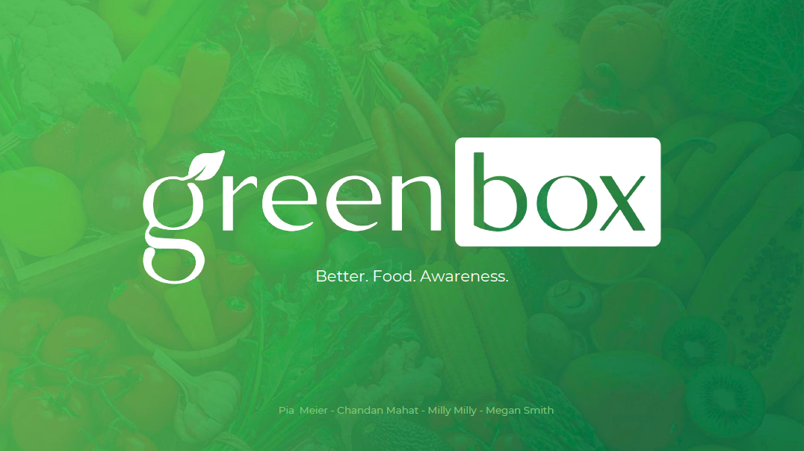

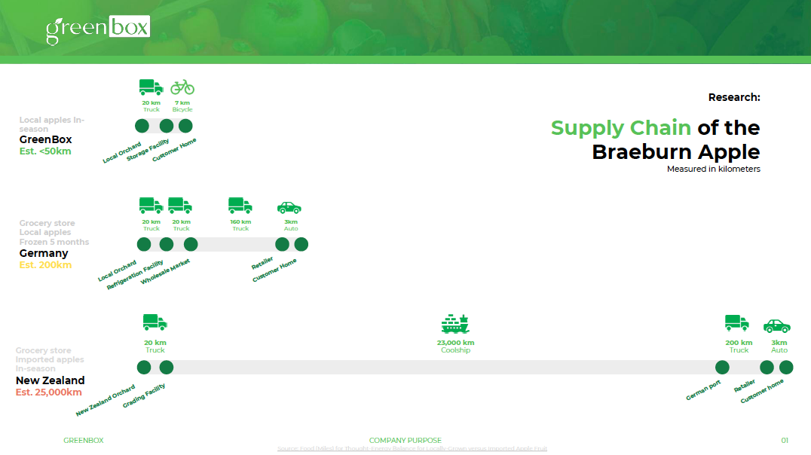

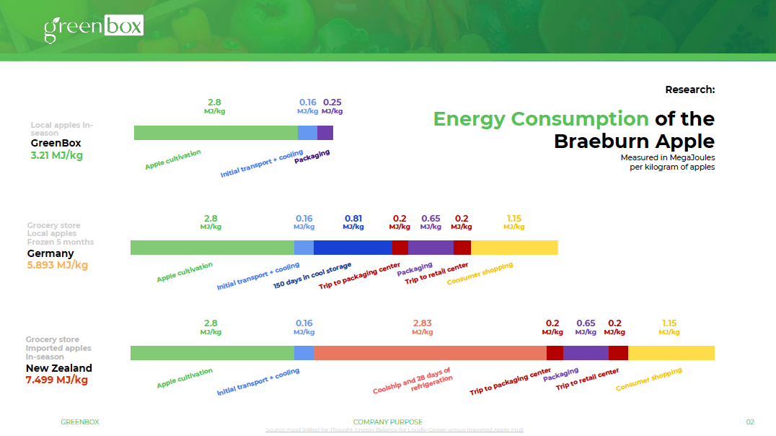

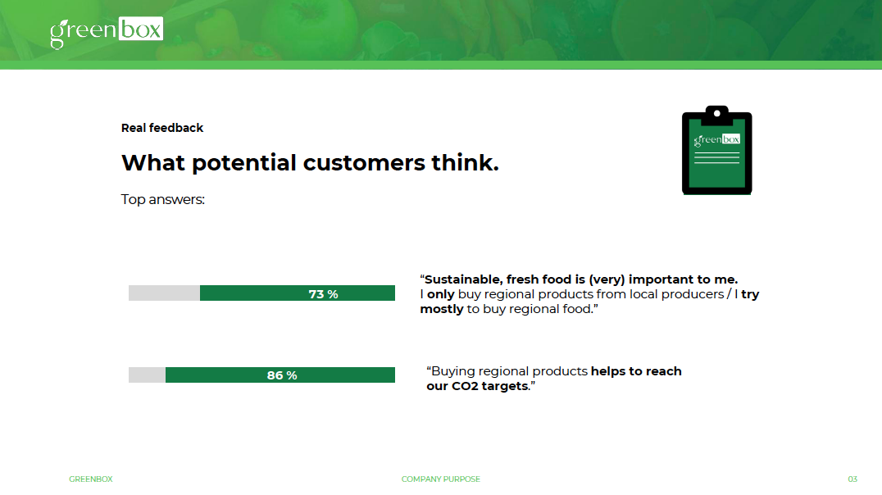

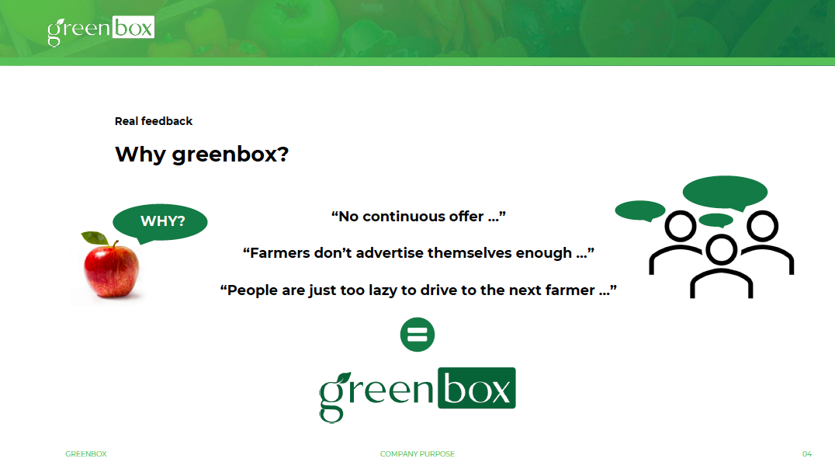

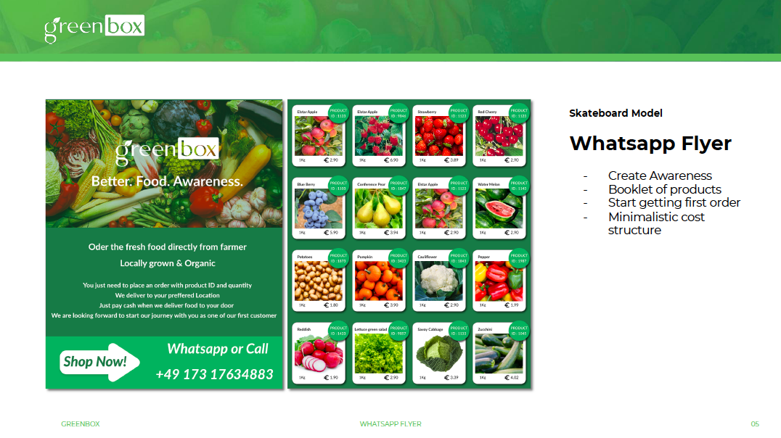

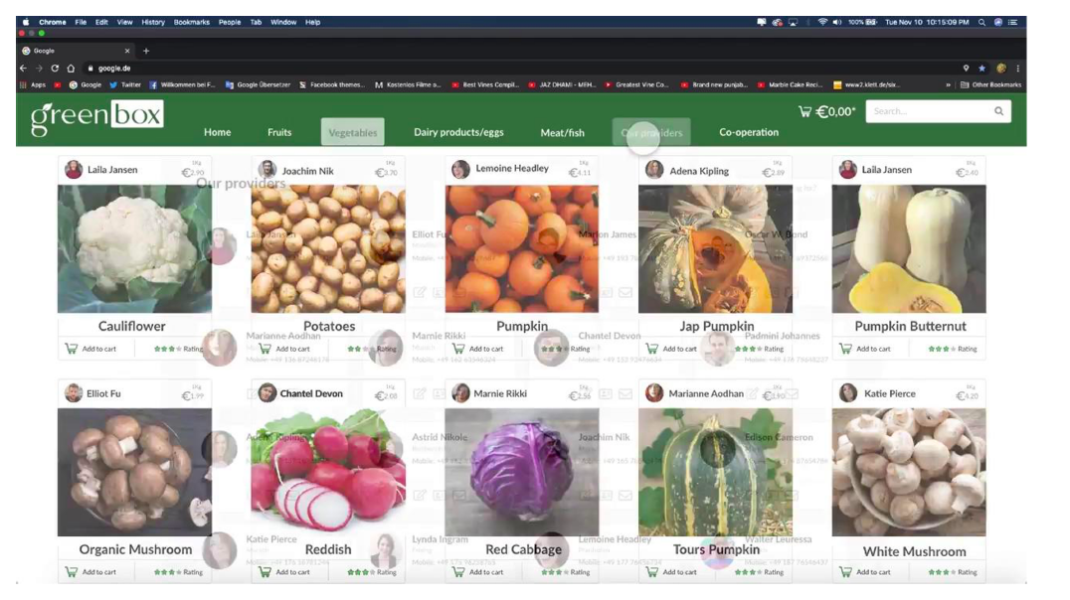

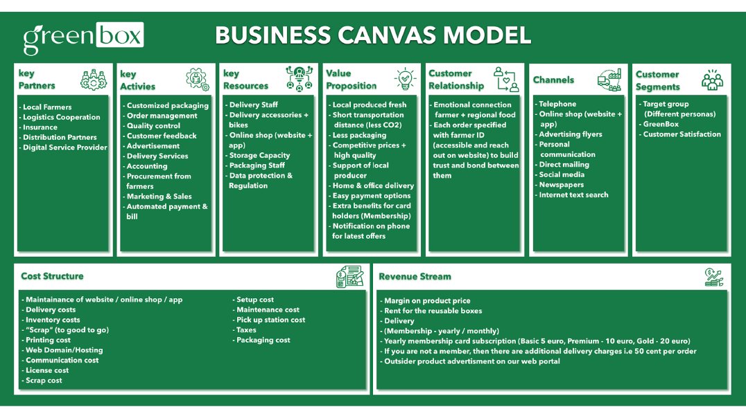

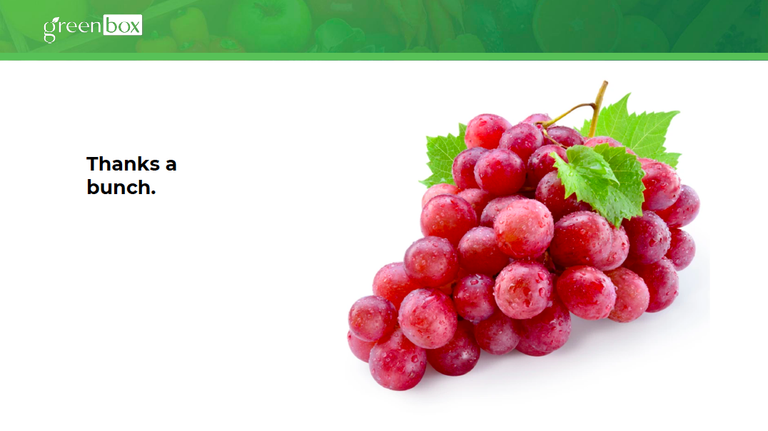

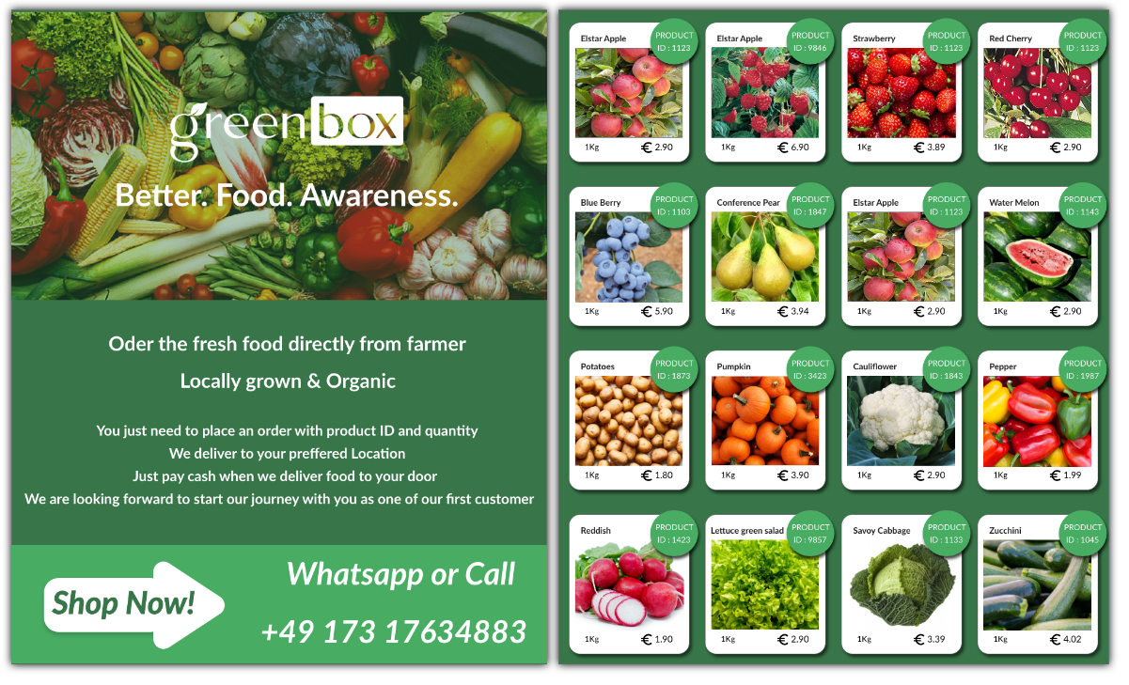

WhatsApp Flyer

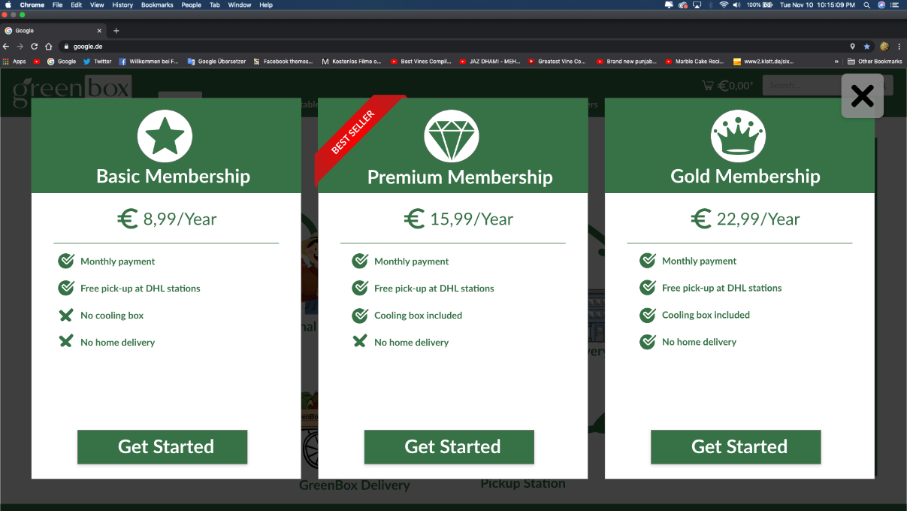

Membership Subscription webpage

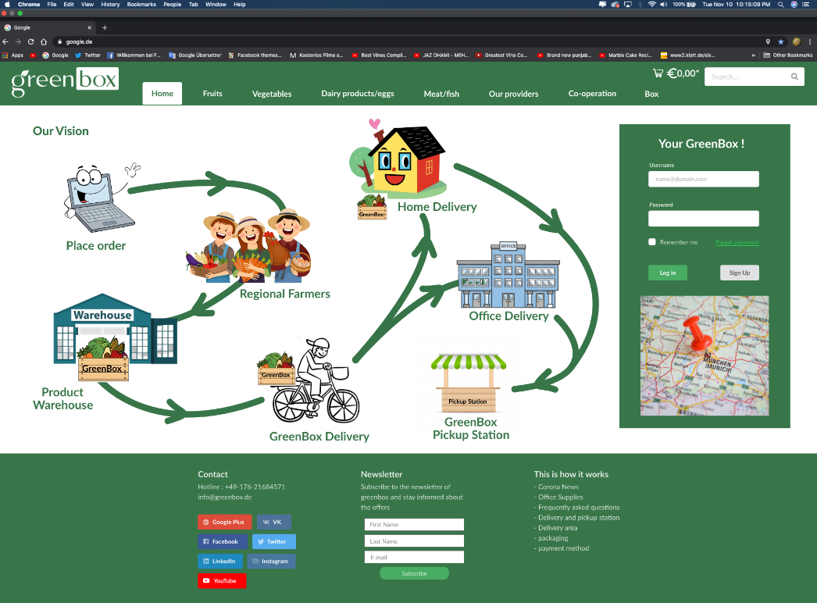

Home page

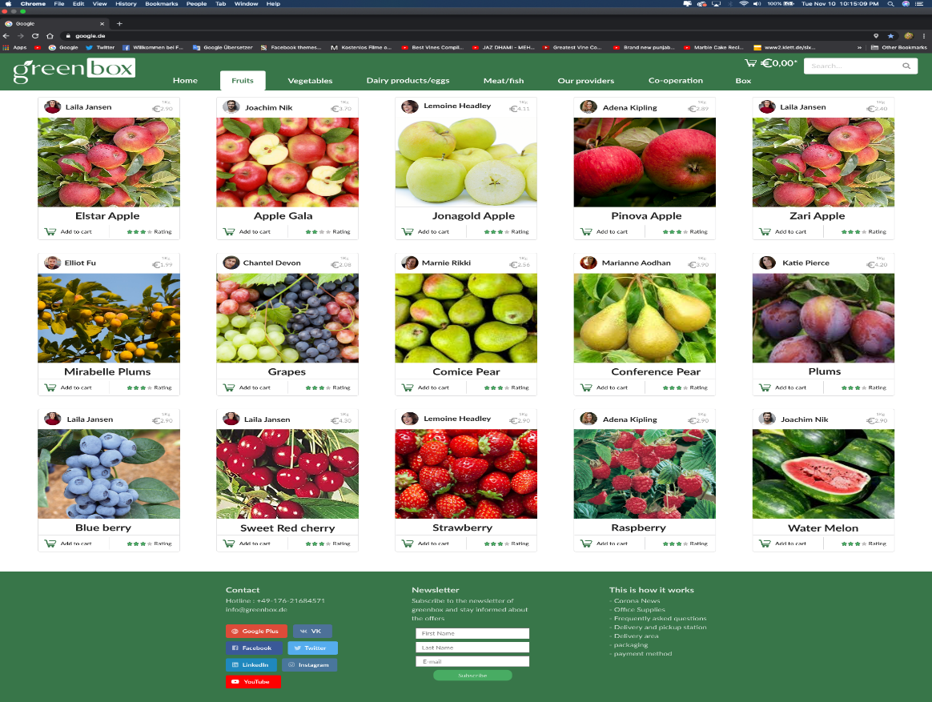

Fruits Page

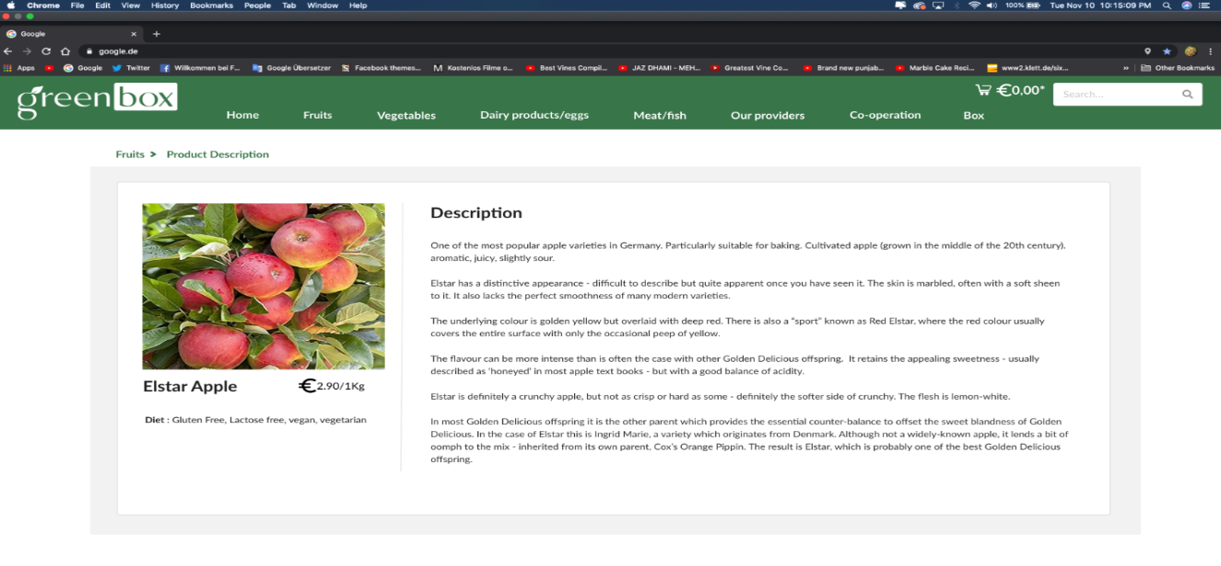

Elster Apple Fruit Product Description

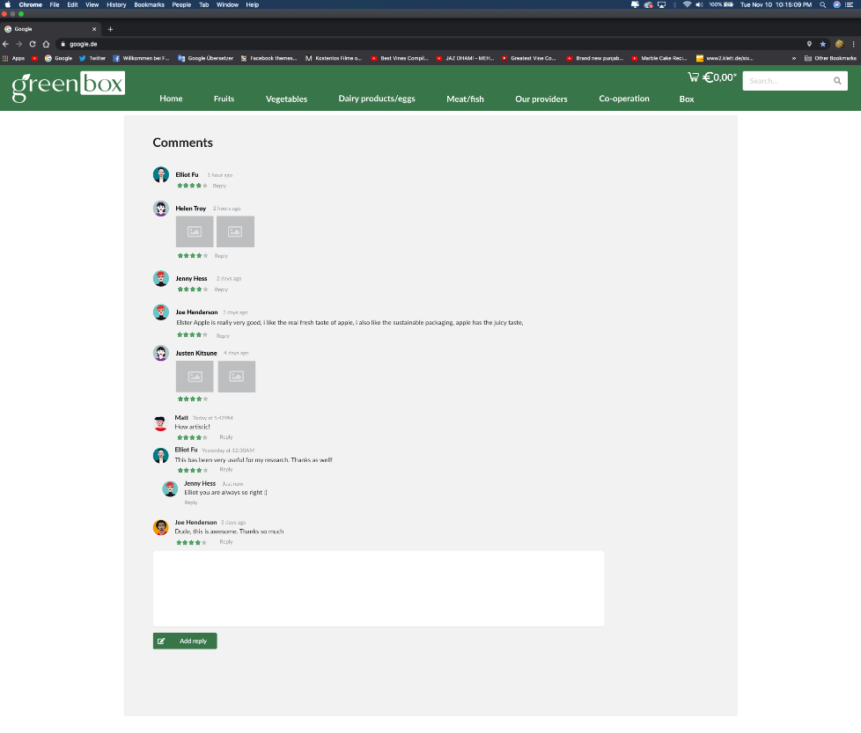

Rating on particular product

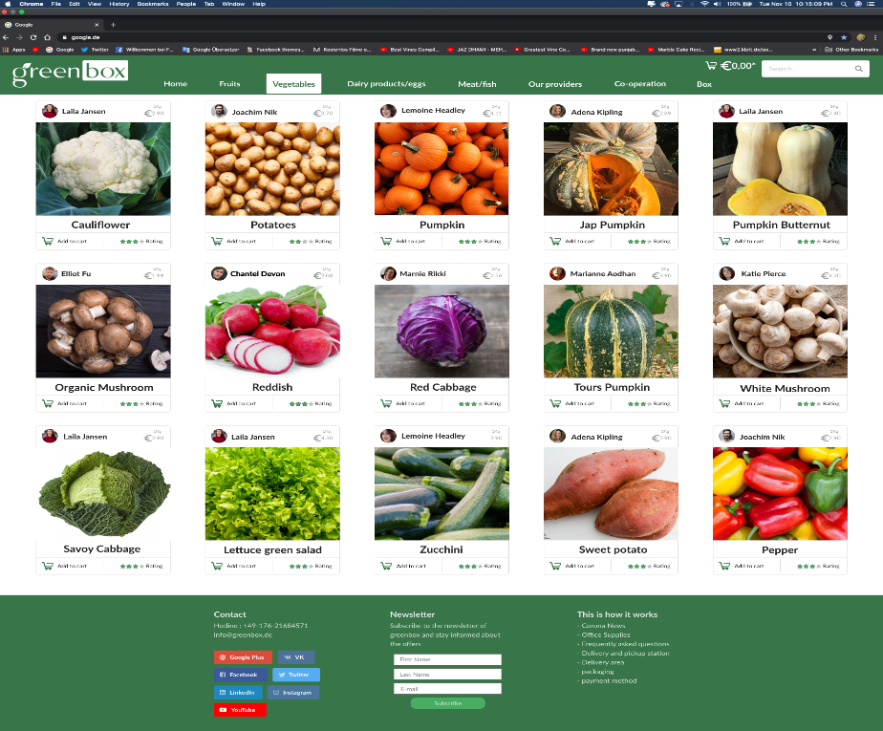

Vegetables page

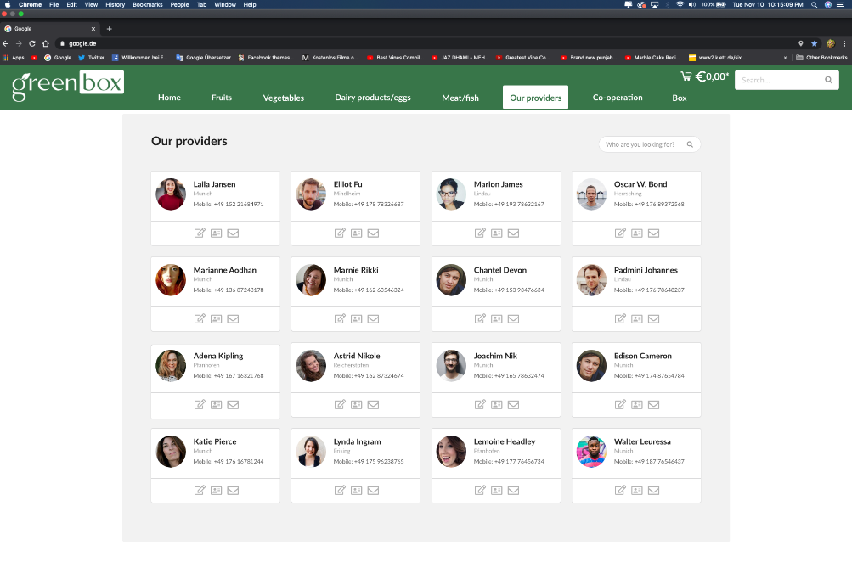

Our provider page

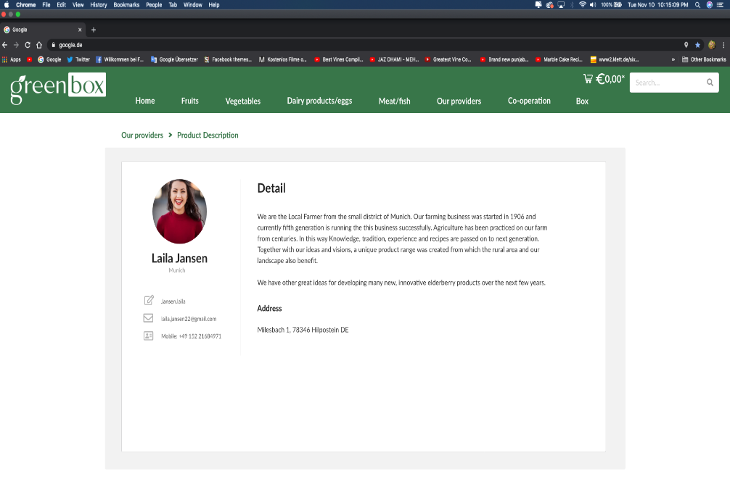

Farmer Detail

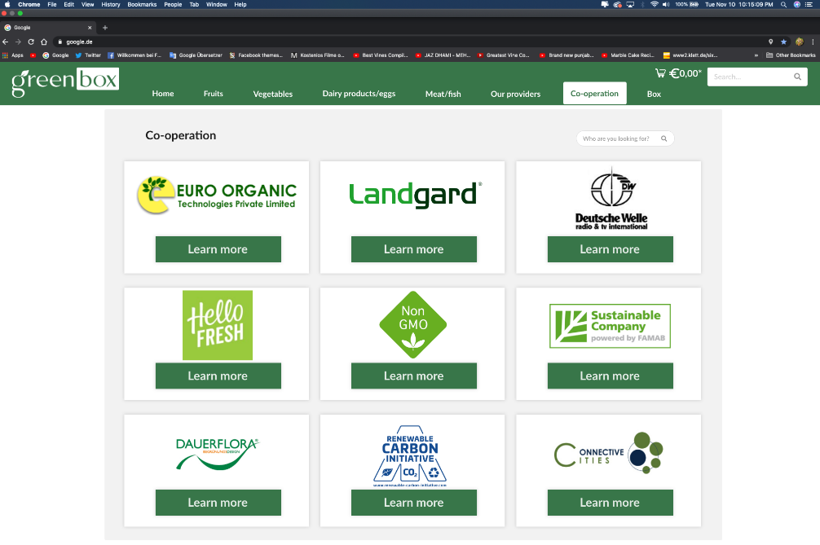

Co-operation details

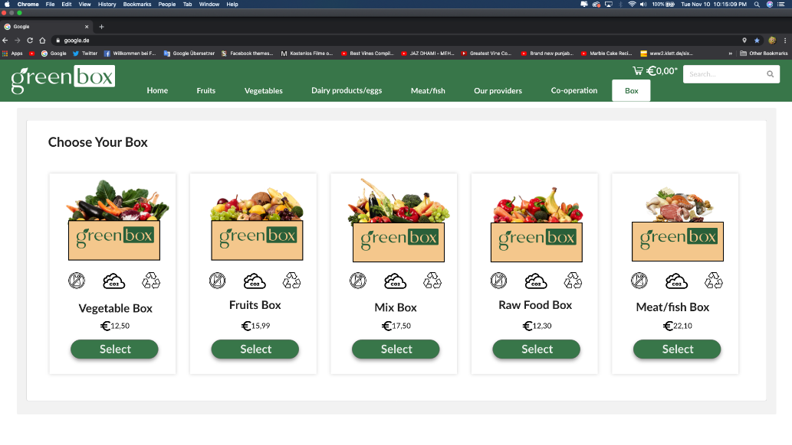

Select customizable box

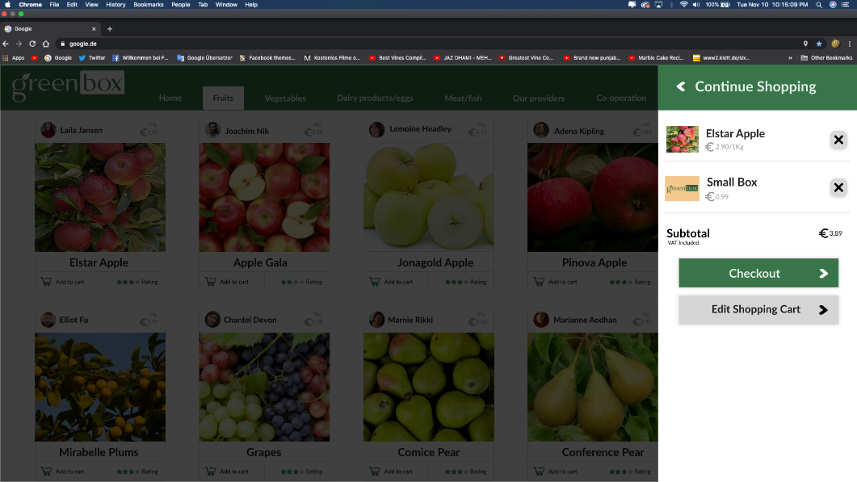

Add to cart

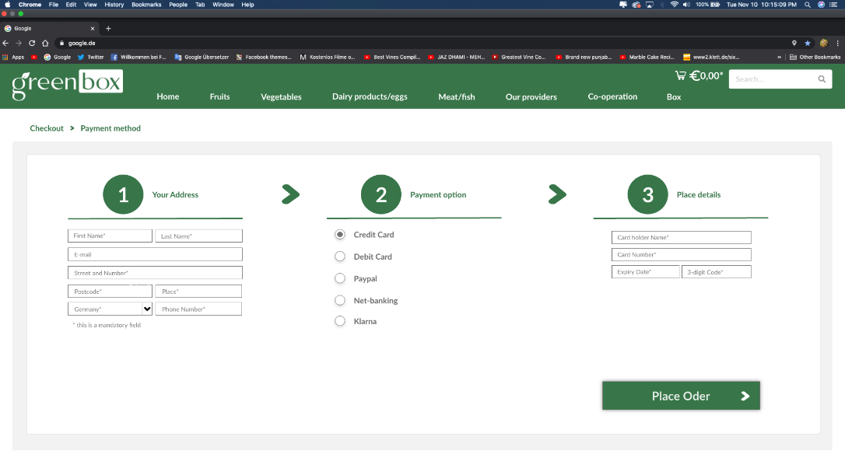

Payment method

